H.T No
Regulations:
A20

Sreenidhi Institute of Science and Technology
(An Autonomous Institution)
Code No: 8AC42 Date: 28-Mar-2023 (AN)

B.Tech I-Year II- Semester External Examination, March/April-2023 (Supplementary)
ELECTRICAL CIRCUITS AND NETWORKS ANALYSIS (ECE)

Time: 3 Hours Max.Marks:70

Note: a) No additional answer sheets will be provided.
b) All sub-parts of a question must be answered at one place only, otherwise it will not be valued.
c) Missing data can be assumed suitably.
Bloom's Cognitive Levels of Learning (BCLL)

Remember | L1 | Apply | L3 | Evaluate | L5
Understand | L2 | Analyze | L4 | Create | L6

Part - A Max.Marks:20

Answer all QUESTIONS.

 |  | BCLL | CO(s) | Marks
1 | Differentiate between Unilateral and Bilateral Networks | L4 | CO1 | [2M]
2 | Define Form factor and Peak Factor? | L1 | CO2 | [2M]
3 | What is Magnetic field and magnetic lines of force? | L1 | CO3 | [2M]
4 | State Norton’s Theorem | L1 | CO4 | [2M]
5 | Classify different types of two port network parameters? | L3 | CO5 | [2M]
6 | Explain initial conditions of Capacitor? | L2 | CO6 | [2M]
7 | Define i) charge ii) electric current iii) power | L1 | CO2 | [2M]
8 | Write some applications of maximum power transfer theorem. | L1 | CO4 | [2M]
9 | An RL circuit with R = 12 Ω has time constant of 5ms. Calculate the value of the inductance. | L3 | CO6 | [2M]
10 | Compare electrical circuit and magnetic circuit? | L5 | CO2 | [2M]

Part – B Max.Marks:50
ANSWER ANY FIVE QUESTIONS. EACH QUESTION CARRIES 10 MARKS.

 |  |  | BCLL | CO(s) | Marks
11. | a) | Derive the relationship to express three star connected resistances into equivalent delta? | L5 | CO1 | [5M]
 | b) | Find the current I in the circuit shown in fig. by using nodal analysis  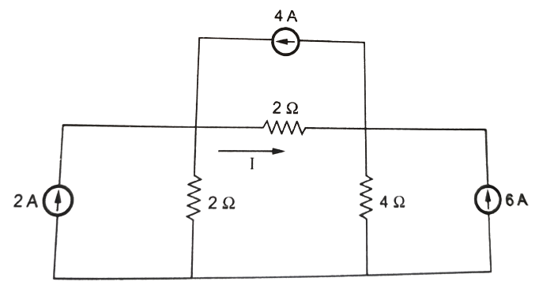 | L3 | CO1 | [5M]
12. | a) | Find the form factor for the following waveform  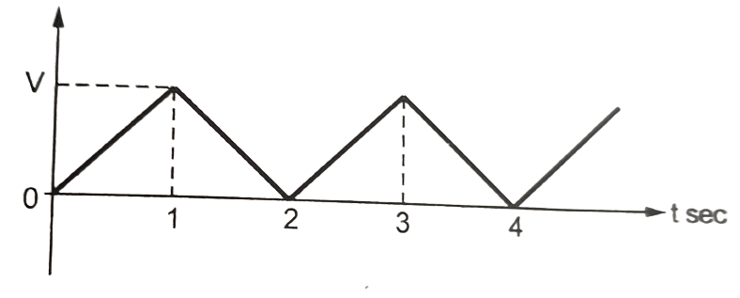 | L3 | CO2 | [5M]
 | b) | A series RLC circuit has R=10Ω, L=0.5H and C=40μF. The applied voltage is 100V. Find (a) Resonant frequency & Quality factor of a coil (b) Bandwidth | L3 | CO2 | [5M]
13. | a) | Explain in brief the concept of Self inductance and Mutual inductance? | L2 | CO3 | [5M]
 | b) | Derive the expression of equivalent inductance of two series connected coupled coils? | L5 | CO3 | [5M]
14. | a) | Verify Superposition theorem for 4Ω resistor for the following circuit  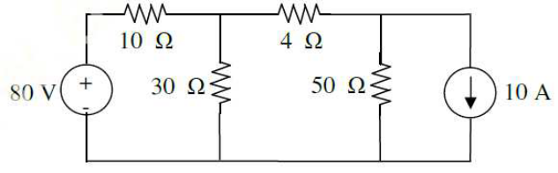 | L4 | CO4 | [5M]
 | b) | State the steps to solve the Thevenin’s Theorem | L1 | CO4 | [5M]
15. | a) | Find the Z- parameters for the following circuit  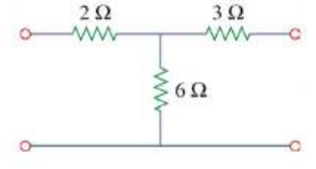 | L3 | CO5 | [5M]
 | b) | Derive the condition of Reciprocity for H-parameters | L5 | CO5 | [5M]
16. | a) | Derive expression for transient response of series R-L circuit driven by DC excitation by using differential equation method? | L5 | CO6 | [5M]
 | b) | The switch is moved from position 1 to 2 at t=0. Find the voltages V_{R}(t) and V_{C}(t) for t≥0.  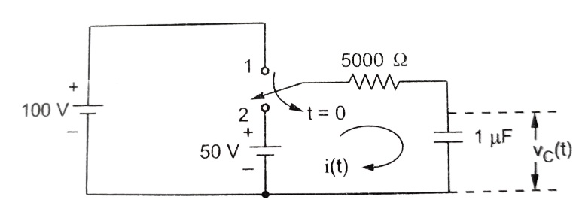 | L3 | CO6 | [5M]
17. | a) | Explain the concept of source transformation with suitable example? | L6 | CO1 | [4M]
 | b) | Derive the expression for Q-factor for Inductor? | L5 | CO2 | [3M]
 | c) | State and explain the Fleming’s Right hand rule and Lenz’s Law? | L1 | CO3 | [3M]
18. | a) | State and explain Norton’s theorem? | L1 | CO4 | [4M]
 | b) | Express Z parameters in terms of ABCD parameters. | L3 | CO5 | [3M]
 | c) | Explain under damped response of series RLC circuit for DC excitation? | L6 | CO6 | [3M]

-- 00 -- 00 –

